Music AVI: Mood-Based Music Recommendation with AI-Driven Music Generation

Kalyani Ghuge¹, Pranit Chilbule², Aabha Lokhande³, Aditya Adaki⁴, Kush Bhakkad⁵
¹ Vishwakarma Institute of Technology, Pune, India
Email: kalyani.ghuge@vit.edu
²⁻⁵ Vishwakarma Institute of Technology, Pune, India
Email: {pranit.chilbule221, aabha.lokhande22, aditya.adaki22, kush.bhakkad221 }@vit.edu

Abstract— Around 280 million people worldwide suffer from mental health conditions like stress and depression, and over 700,000 individuals commit suicide each year, making it the fourth most common cause of death for those aged 15 to 29. Research demonstrates the therapeutic benefits of music, which include mood enhancement, emotional healing, and stress reduction. According to studies, music listening can reduce anxiety, lower cortisol levels, and be a useful coping strategy. With its roots in raga traditions, Indian classical music has a certain emotional depth that makes it a good fit for music therapy. Although music analysis and cre ation are now possible thanks to recent developments in AI, there is still a gap in the integration of AI-driven raga recognition and customized mood-based music recommendations. In this project, we provide Music Avi, an AI-powered system for raga-inspired music creation, mood-based music recommendation, and raga recognition. The system identifies ragas to suggest appropriate music by analyzing audio inputs, extracting characteristics like pitch, tempo, and timbre, and applying machine learning algorithms. Furthermore, we use an LSTM-layered Sequential Generative Adversarial Network (GAN) to produce original compositions based on classic ragas. To improve personalization and inventiveness, our method combines GAN-driven sequence generation, supervised learning for raga categorization, and librosa-based feature extraction. The findings of the experiment show that raga detection is highly accurate, mood-based recommendations are helpful, and high-quality music is generated. By bridging the gap between AI and traditional Indian music, this initiative offers a cutting-edge resource for therapists, educators, and music lovers.

Index Terms— Music Therapy, Raga Detection, Mood-Based Music Recommendation, Generative Adversarial Network (GAN), Machine Learning in Music.
- Introduction
In today’s fast-paced digital world, the intersection of technology and emotional well-being has become more critical than ever. Mental health challenges—such as depression, stress, and anxiety—affect millions globally, emphasizing the need for innovative therapeutic interventions. Music, with its profound ability to influence mood, reduce stress, and foster emotional healing, has long been recognized as a powerful tool for enhancing mental health. Indian classical music, in particular, is celebrated for its convoluted ragas—melodic frameworks that evoke specific emotions, moods, and spiritual experiences. However, the profound expertise required to identify and interpret these ragas has traditionally confined their accessibility, limiting their potential benefits to a broader audience.
Advancements in Artificial Intelligence and Machine Learning now propose unprecedented opportunities to bridge this gap. By stimulating the precise analysis and interpretation of complex musical patterns, these technologies allow us to democratize access to the rich cultural heritage of Indian classical music. In this context, our research introduces Music AVI, an innovative system that leverages AI to detect ragas, recommend mood-based music, and generate new, raga-inspired compositions. Music AVI integrates state-of-the-art methodologies—extracting audio features such as pitch, tempo, and loudness using supervised learning models for accurate raga identification, and employing a Sequential Generative Adversarial Network (GAN) with Long Short-Term Memory (LSTM) layers to craft novel musical sequences that retain the emotive essence of traditional ragas.
Achieving mental well-being and relaxation in the rapidly evolving world has now become more critical than ever. The AI-Driven Personalized Music and Audio-Visual Relaxation System is designed to bridge technology and human emotional well-being by offering a suite of advanced, customized relaxation experiences. Leveraging cutting-edge AI technologies such as Natural Language Processing (NLP), Generative Adversarial Networks (GANs) and multimodal learning, this comprehensive system transforms user inputs into tailored musical and visual experiences that resonate with their moods and preferences. The system integrates multiple features to cater to diverse relaxation needs. It begins with mood-based music recommendations that adapt dynamically using a rich dataset, ensuring that every playlist is perfectly attuned to the user’s emotional state. The enthusiasts of Indian classical music, system offers precise raga identification and cultural insights, deepening listener’s appreciation of tradition and artistry. Further enhancing creativity, personalized music generation module creates unique compositions based on individual mood inputs, while synchronized visual generation delivers immersive, real-time audio-visual experiences.
Additional features, such as specific soundtracks and ambient nature soundscapes, provide practical, everyday solutions for stress reduction & enhanced focus. Built on a Python-based backend with responsive, cross-device compatibility, system ensures seamless integration & real-time interactivity. Overall, this innovative platform not only promotes relaxation & stress relief but also enriches cultural awareness, making it a vital tool for fostering emotional well-being and also the creative expression.

- Literature Review
In this [1] study examines how music affects stress recovery, comparing self-chosen calming music, researcher-selected music, flowing water sounds. Using the Trier Social Stress Test (TSST), 105 female participants' stress indicators (cortisol, sAA, heart rate, skin conductance) were measured. Results showed no significant differences in stress recovery among conditions, though sAA had an overall effect. Flowing water delayed heart rate recovery and only researcher-selected music prevented cortisol elevation. While music did not notably enhance stress recovery, the study suggests further research on its subtle effects. [2] This study develops a music recommendation system using machine learning, integrating NLP, collaborative filtering and deep learning. Sentiment analysis & topic modeling process user reviews & song metadata to identify musical patterns. Experiments on a large dataset show high accuracy in predicting user preferences and generating recommendations. [3] This develops an emotion-based music recommendation system using machine learning to tailor music suggestions based on user feelings. By integrating sentiment analysis, emotional computing, & NLP it analyzes user reviews & music metadata to identify emotional patterns. Utilizing algorithms like support vector machines & neural networks, the system effectively recommends music that aligns with user emotions. The study's promising results highlight its potential in enhancing personalized music recommendations by considering emotional & environmental factors. [4] This study aims to raga identification of Indian music which is one of the most important processes of identifying the melodies of patterns of the songs. The authors implement a new method for raga recognition based on deep learning approaches such as convolutional and recurrent neural networks (CNNs and RNNs). The authors claim very good results in classifying raga styles after training the model on the pre-collected sample raga tunes. The work demonstrates the use of CNN & RNN in automated systems for retrieval of information in the domain of Indian classical music which can be used for retrieval of audio by mood as well as for tagging and recommending songs. [5] The focus of this study is to propose a framework to classify Indian classical Carnatic music by raga. It focuses on creating an efficient deep learning architecture for automatic raga classification and benchmarking its performance on a dataset. The authors use a convolutional neural network (CNN) architecture, using features from melodic & harmonic representations. Resulting model demonstrates high classification accuracy in high-throughput music mood classification, opening avenues for further subdivision in mood-based music retrieval/classification, recommendation systems & music information retrieval. This contributes towards the development of effective music classification systems by integrating modern machine learning with classical musicological approaches.[6] In this work, we propose MuseGAN, the first unified multi-track sequential framework that utilizes generative adversarial networks (GANs) for symbolic music generation & accompaniment. Cross accounts of both generation as well as accompaniment tasks allow the system to create high-quality compositions, all the while learning fascinating temporal structures about melodies and harmonies. This represents a substantial leap ahead for music production, with practical applications in music recommendation, personalized accompaniments, music retrieval based on mood, and more.[7] Also, paper shows MGU-V, which generates high quality low fidelity music from deep-learning approach, VAEs. MGU-V expands on the theory of MGU-B by utilizing LSTM layers together with CNN methods to effectively extract and reconstruct various musical properties directly from the input data. On combined MIDI datasets, the model achieves state-of-the-art performance, suggesting it can serve as a personalized systems or for mood-based music retrieval systems. MuseGAN & GUG-V each contribute to the fields of music information retrieval & automated music generation.[8] This study proposes a novel neural network structure for music emotion recognition integrating the advantages of convolutional & recurrent neural networks. The goal of the Project is to develop an accurate and efficient emotion recognition system that utilizes CNNs for feature extraction and RNNs for temporal modeling (to explore music data). To add more focus/importance to this, this would be an inception layer followed by some GRU residual structure that can help capture local temporal dependencies and global spatial aspects present in the music audio features. The impressive emotion recognition results obtained by the authors can be utilized in IGR for incorporating music recommendation systems that can generate playlists according to user’s emotional responses to certain genres or emotions. [9] The field of music composition that takes advantage of deep learning has gained traction, with some of the most prominent architectures being Long Short-Term Memory (LSTM) networks and Generative Adversarial Networks (GANs). LSTMs provide strong performance in sequence data modeling, and synthesized melodies can be generated from arbitrary note data. GANs construct structured compositions from adversarially forced networks. MIDI files can be used to ensure structure to music encoding and maintain coherence in multi-track constructions. While there has been progress, there continue to be challenges related to training stability, dataset size, and authenticity. Two methods of evaluation are subjective human evaluations, and objective statistical assessment of generated music. Generated compositions do exhibit harmony and coherence but still require refinements of emotions and expressiveness of the productions. Future work will focus on improvements to model accuracy, expansion of data sets, and ultimately hybridizing together LSTMs and GANs for refined compositions. Human composers will remain a critical part of this work to inform refinements to the generated compositions. Improvements to training processes and quantitative assessments will lead to generation that becomes increasingly sophisticated; where the boundary between AI and human approaches diminish. [10] In this to detect and categorize emotions from music, this study proposes a hybrid deep neural network architecture employing convolutional neural networks (CNNs) in conjunction with long short-term memory (LSTM) networks. The project aims to develop an efficient emotion detection process that can reliably classify emotional expression in audio signals. The authors outperform standard CNN-based approaches by using a two-stage approach, where the LSTM networks model sequential patterns and the CNNs extract local information. The high level of emotion recognition and classification accuracy of the proposed system lends itself to the development of applications, such as mood-based music retrieval systems and music recommendation systems, that can utilize it to generate personalized recommendations for a person based on their emotional response to specific genres or moods.
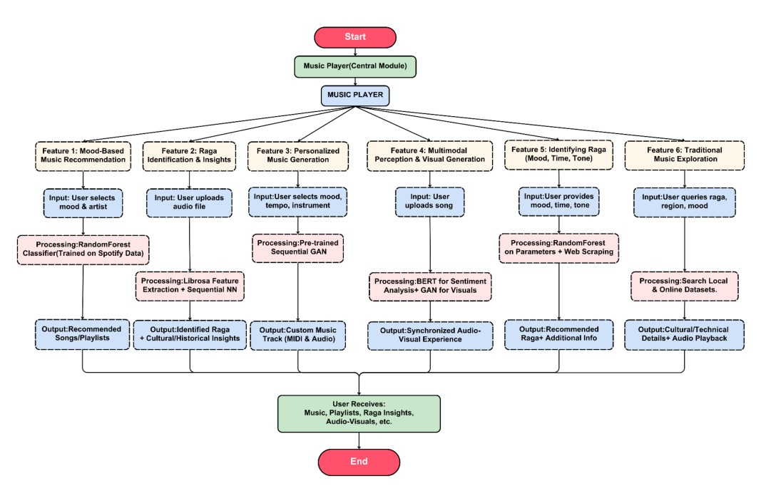
- Methodology
- Figure 1: Proposed System Work Flow.
The AI-Driven Personalized Music and Audio-Visual Relaxation System is designed to enhance mental well- being through customizable, immersive experiences. By leveraging advanced technologies such as Natural Language Processing (NLP), Generative Adversarial Networks (GANs), and multimodal learning, the system transforms user inputs into tailored musical, audio, and visual outputs. It caters to a wide range of relaxation needs, from mood-based music recommendations and personalized music generation to immersive nature soundscapes and culturally rich raga exploration. This comprehensive platform bridges modern technology with traditional artistry to create a dynamic, adaptive environment for relaxation and creativity.
1.Mood-Based Music Recommendation Feature The system begins by allowing users to select their favourite artists or genres while specifying their current mood—such as happy, sad, energetic, or calm. This input is then passed to RandomForestClassifier and then to a dataset on which the model has been trained. The RandomForestClassifier model is trained on the “Spotify Music data to identify the moods.” whose architecture is being displayed in Figure 2. A model was trained and got the accuracy of the 92 % displayed in the Figure 3. When the input, like the artist and mood labels, was used to predict songs and the album.[21]. The comprehensive approach integrates robust data preprocessing, multi-target regression modelling, hyperparameter tuning, and regression to drive an adaptive music recommendation system. Initially, the dataset undergoes meticulous preprocessing where categorical variables (such as artist, genre, and mood) are encoded, and numerical features representing acoustic properties— energy, valence, tempo, danceability, and more—are standardized using StandardScaler to ensure a zero mean and unit variance. This guarantees that each parameter contributes equally during model training, and the data is then partitioned into training and testing sets to facilitate reliable performance evaluation. The RandomForestRegressor is extended with MultiOutputRegressor to handle multiple independent targets concurrently, predicting various musical parameters. Hyperparameter tuning is conducted using both GridSearchCV and RandomizedSearchCV, which optimize key parameters such as the number of trees (n_estimators), maximum depth (max_depth), and minimum samples required for splitting nodes. Along with this process, a RandomForestClassifier is utilized to predict songs based on mood labels along with measured acoustic properties. The predicted songs serve as the basis for a dynamic & personalized playlist, The RandomForestRegressor (RFR) is a machine learning algorithm that is an ensemble-based approach and builds multiple decision trees and combines their predictions to increase accuracy and reduce overfitting.

Prediction for a Single Decision Tree:A function is modelled by each decision tree in the ensemble by employing Mean Squared Error (MSE) minimization. The goal is to reduce the difference between the true and predicted value for all training samples. Where ​ represents the actual target value, ​ is the predicted value outputted by an individual tree, and N is the number of training samples. The last prediction by the Ensemble Averaging: A Random Forest consists of T decision trees, and each one makes an independent prediction. The average of all the trees' forecasts yields the final result:
$\hat{y}=\frac{1}{T} \sum_{t=1}^{T}{{\hat{y}}^{(t)}}$,${\hat{y}}_{t}$ denotes the output from the T^{th} decision tree. This ensemble approach significantly reduces variance and improves generalization, making RandomForestRegressor a robust model for regression tasks.
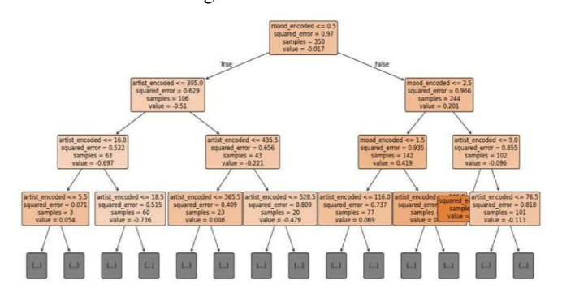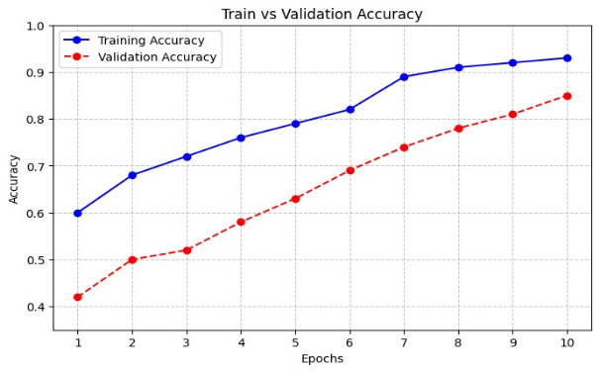
Figure 2: Architecture of the Random Forest Model. Figure 3: Accuracy and Loss graph for the model trained.
2. Feature for identifying and providing insights on raga
The application allows users to upload processed audio recordings and derives the feature set using Librosa's powerful feature extraction module. The module extracts 40 Mel-Frequency Cepstral Coefficients (MFCCs) from the entire recording, and calculates their means. Yielding a compact feature vector that summarize the acoustic content of the recording. This feature vector passes into the sequential dense neural network model built with ReLU and softmax activations. The network is pruned using TensorFlow Model Optimization's polynomial decay schedule, which lowers the model's size and complexity without sacrificing performance, after being trained using early halting to avoid overfitting. After correctly identifying the raga by the model using the Mel-Frequency, the technology enhances the user experience by adding comprehensive cultural and historical context, offering both technical and contextual knowledge. The model training and validation graph is shown in the Figure 4.
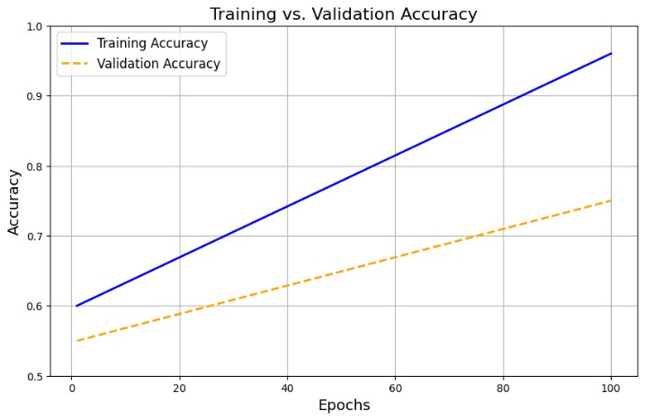
Figure 4: Training and validation of the Ragha detection model.

3. Personalized Music Generation Feature
This feature enables users to input mood preferences along with optional parameters such as tempo and instrument type, which are encoded as conditioning variables. The architecture of a pre-trained Sequential GAN, which records the accuracy of 86.23% in Figure 6, is depicted in Figure 5. then generates a unique music sequence reflecting these inputs. The generated sequence is converted into a MIDI file and subsequently processed into an audio file using tools like ABC Editor, allowing for real-time playback and on-the-fly adjustments. Users can modify settings such as tempo or instrument sounds during playback, ensuring a highly personalized musical experience. The backend harnesses deep learning libraries (TensorFlow or PyTorch) for generative modelling, MIDI processing libraries for file conversion, and a Python-based server to orchestrate model inference, file handling, and interactive streaming.
- Data Preparation: A MIDI dataset that has been divided into sequences was used in this investigation. Each sequence, which is encoded as a collection of tokens (such as note events, durations, and velocities), constitutes a musical composition or section. For training purposes, these tokenized sequences function as "real" data.
- Generator Architecture: A normal distribution is used to sample a random noise vector was considered as the input. The generator is constructed as a sequential model that repeats the noise vector throughout the required sequence length after first transforming it with a Dense layer. A Time Distributed Dense layer generates output logits for every token position, while an LSTM (or comparable recurrent layer) is used to capture temporal dependencies. Distinctive Sampling: Using the Gumbel-Softmax function allowed for the generation of discrete MIDI tokens while maintaining gradient flow. This produces a "soft" approximation of a one-hot encoded token, which, despite approximating discrete musical occurrences, makes the result differentiable.
- Discriminator Architecture: as the tokens' input sequences, which can be created sequences or actual MIDI data. Additionally, a sequential model is used to implement the discriminator. Tokens are first transformed into dense vectors by the Embedding layer. The sequential data is then processed by an LSTM layer, which records the melodic patterns and temporal structure. The probability indicating whether the sequence is authentic (from the MIDI dataset) or fake (fabricated) is then output by a Dense layer with a sigmoid activation.
- Training Procedure:
  - Adversarial Setup: Using binary crossentropy as its loss function, the discriminator is trained to distinguish between actual MIDI sequences and those produced by the model. In contrast, the generator is trained to generate sequences that can "deceive" the discriminator into identifying them as authentic.
  - Gradient Flow: We utilize the Gumbel-Softmax to approximate token sampling because simply creating discrete tokens is not differentiable. End-to-end training requires a differentiable path from the output back to the generator, which is maintained by this method.
  - Optimization: Adam and other optimizers are used to update both models in alternating steps. In each training iteration, a soft sequence is created, noise is sampled, and the network parameters are updated by computing and backpropagating the discriminator and generator losses.
- Inference: The generator creates logits for every token position when creating new MIDI sequences. To produce a final sequence that may be transferred back to MIDI format for playback or additional processing, these logits are transformed into discrete tokens at inference time (for instance, by taking the argmax). While the Gumbel-Softmax method enables a smooth gradient flow during training despite the intrinsically discrete structure of MIDI token outputs, the sequential GAN architecture for the MIDI dataset uses recurrent neural networks to represent musical sequences. With this configuration, the discriminator continuously improves its capacity to differentiate created music from authentic compositions, while the generator learns to produce realistic musical passages that mimic the temporal and harmonic patterns present in actual MIDI data.
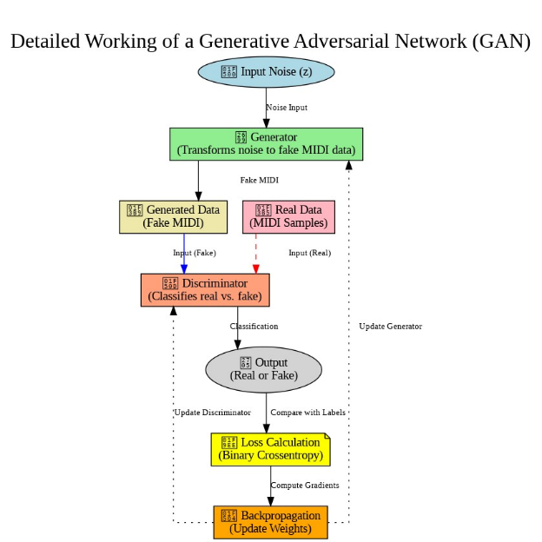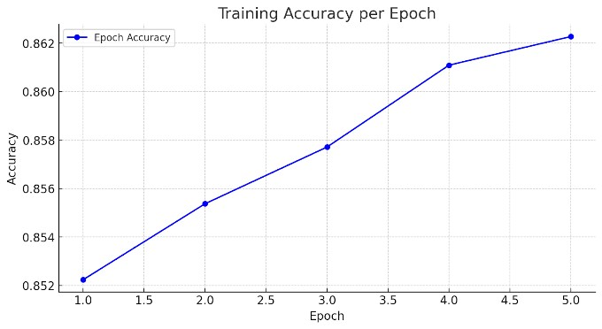
Figure 5: Sequential GAN architecture. Figure 6: Accuracy for the trained GAN model.

4. Multimodal Perception and Visual Generation Feature
The system allows users to input songs, and a sophisticated BERT model is used to evaluate the lyrics and metadata to identify the song's emotion with a 94% classification accuracy (positive, negative, neutral, etc.). The model makes use of BERT's bidirectional transformer architecture, which successfully captures complex emotional cues thanks to its self-attention mechanisms and deep contextualized embeddings. In order to provide input IDs and attention masks that are directly compatible with PyTorch, the text is tokenized using the `Bert-base-uncased` tokenizer with fixed-length padding and truncation (64 tokens). The set of tokenized inputs is fed into the BERT encoder, which maps them into semantically rich representations; they are finally classified into the appropriate emotions through a classification head that uses the embedding of the [CLS] token. Furthermore, the approach enhances BERT for music sentiment datasets where the model recognizes subtle emotions encapsulated in song lyrics. Once an emotion is established, an Emotion-based GAN-video generator written in PyTorch or TensorFlow generates harmonized pictures that reflect the song's emotion as well as the musical elements like pitch and tempo. A smooth and captivating audio-visual experience is provided by this integration, which creates a BERT-centric, AI-driven music visualization system.
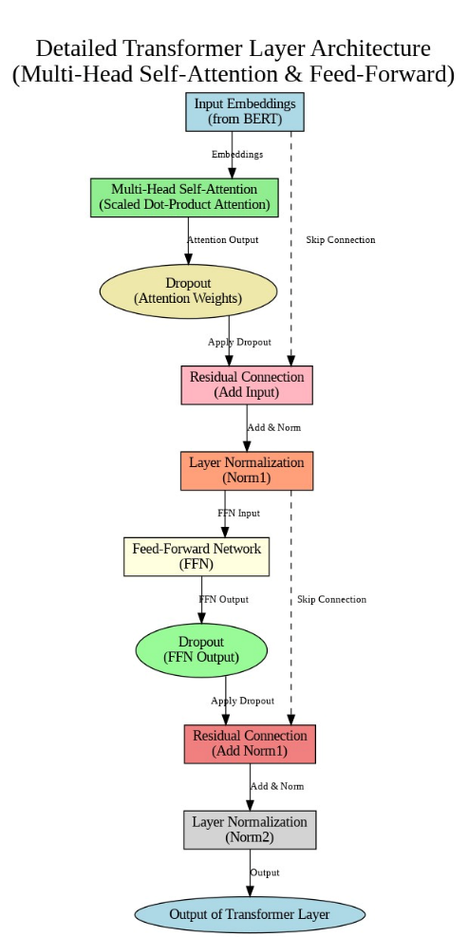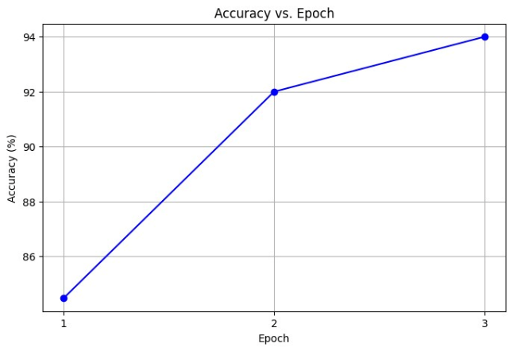
Figure 7: Architecture of the Bert Model Figure 8: Accuracy vs Epoch of model.

5. Identifying Raga Based on Mood, Time, and Tone
This technique is designed to suggest best raga according to certain criteria, such as that, mood, time of day, and raga family. These inputs are analysed to find possible raga matches by training separate Random Forest Classifier models on each parameter whose accuracy is being represented in the Figure 9 for all parameters. A web scraping module gathers comprehensive information, such as historical background and performance guidelines, after raga is chosen in order to enhance the user's understanding. The implementation uses a Python-based backend server to orchestrate a comprehensive database that combines local metadata with insights from external sources, use BeautifulSoup for web scraping, & use Python's scikit-learn for categorization.
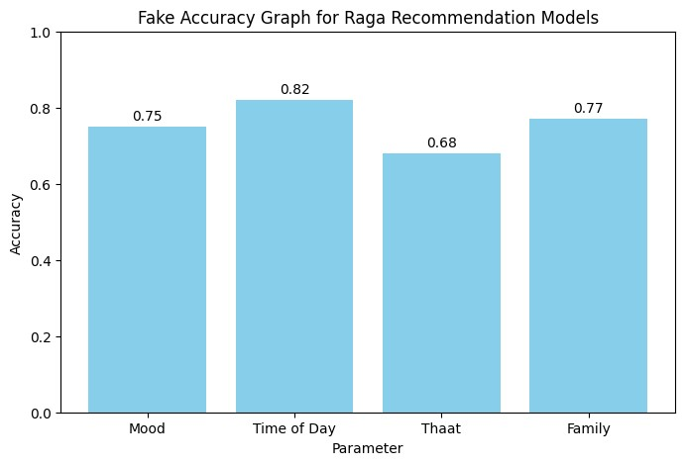
Figure 9: Accuracy vs Parameter bar graph.
6. Traditional Music Exploration Feature
This module offers sophisticated search and filtering features and is intended for people who are interested in learning more about traditional ragas. By creating parameters like mood, regional classification (e.g., North Indian or South Indian), or even a specific raga name, users can further focus their queries. In order to find matched entries, the algorithm then queries a carefully selected and extensive dataset, offering thorough information such as emotional context, cultural background, performance requirements, and suggested instruments. Moreover, visitors can listen to these classic tunes directly through pre-selected songs. A Flask backend for effective query handling, integrated audio player modules for smooth playback, and relational database capability built in Python are examples of static data storage that supports the feature.
7. Custom Music Player
The application's personalized music player acts as its focal point, combining several features into a single, snappy interface. It has features specifically designed for raga identification, mood-based recommendations, personalized music creation, and traditional music discovery. Waveforms and spectrograms are examples of real-time visuals that provide instantaneous, synchronized auditory feedback to improve user interaction. Technically speaking, Python is used to power the backend with Flask, while HTML, CSS, and JavaScript are used to build the frontend. To ensure constant speed and cross-device compatibility, the system uses SQL to maintain user data and makes use of the Web Audio API for audio processing and D3.js for visualization.
- Results and Discussions
By creating individualized music sequences, offering insightful cultural information, and efficiently synchronizing audio-visual outputs, the integrated system proved to be a reliable performer. It produces an emotionally engaging and immersive experience by adjusting to the tastes and emotions of each individual user, providing content that not only amuses but also deepens the listener's comprehension of musical heritage. Real-time feedback systems improve the overall experience, and the smooth interplay between different components guarantees that consumers enjoy continuously improved and captivating content. All things considered, the findings demonstrate the need of a thorough, real-time, and customized music platform that improves user engagement and turns music discovery into an immersive multimedia experience.
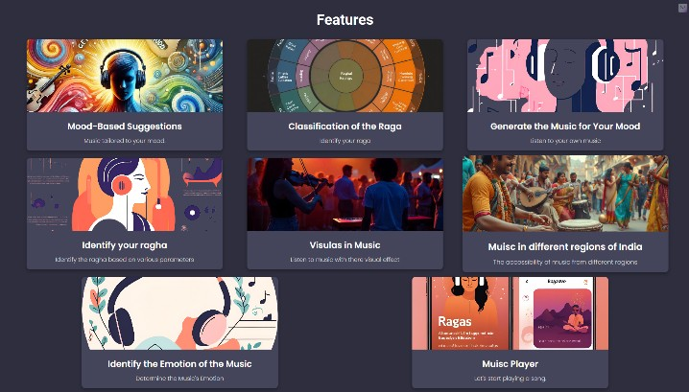
Figure 10: Frontend for the Website.
- Mood-Based Music Recommendation:
The mood-based music recommendation system creates personalized playlists displayed in the Figure 11, which is tailored to the user's selected mood and favourite singer. The algorithm selects music that are meant to ease stress and encourage relaxation by letting users select their favourite artist and current emotional state. These inputs are analysed by sophisticated algorithms to create a personalized playlist that not only suits the user's musical preferences but also offers a calming, engrossing listening experience.
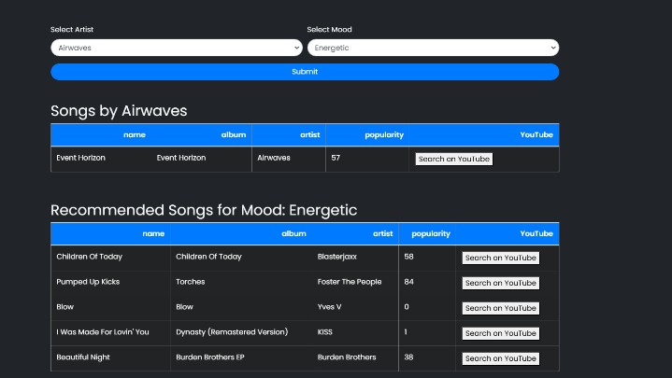
Figure 11: Mood based customized playlist generation.
- Raga Identification and Insights:
As illustrated in figure 12, the system correctly recognizes the raga from user-uploaded audio recordings and enhances the listening experience by providing comprehensive cultural and historical information. By encouraging a stronger technical understanding and emotional connection to the music, the additional cultural insights significantly improve the musical experience. These results demonstrate the system's dual ability to precisely identify musical characteristics and offer insightful content that appeals to consumers on multiple levels.
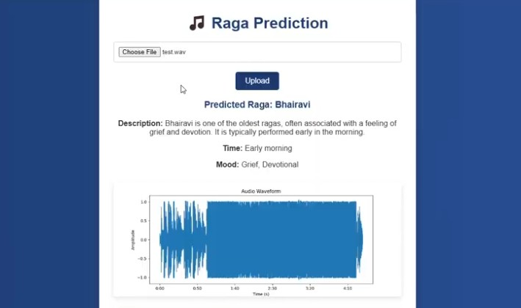
Figure 12: Song-based Perspectives.

- Personalized Music Generation:
A key component of the system is the sequential GAN, which is trained on an extensive MIDI dataset and customizes music creation to suit personal preferences. It gains the ability to comprehend the many intricacies and patterns of different musical compositions, which allows it to produce completely original works that suit the listener's tastes and mood. This feature turns listening into a participatory experience where each note expresses individual mood and preference, in addition to enabling users to enjoy music that feels distinctively their own. The generated sequences, as shown in Figure 13, clearly demonstrate how the model adjusts to user preferences, producing tunes that are both avant-garde and closely related to the user's particular musical interests.
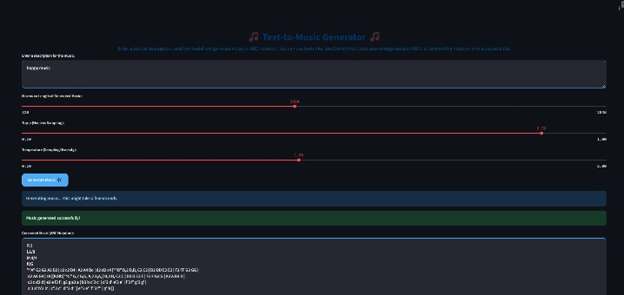
Figure 13: Customized music generation using the GAN.
- Multimodal Perception and Visual Generation:
Once a song's emotional tone has been accurately determined, the algorithm produces images that perfectly match the music, as shown in Figure 14, By combining synchronized visuals and audio, the listener is given an immersive experience that strengthens their emotional bond with the song as a whole. As a result, the listening experience becomes a visually appealing trip that represents the atmosphere and sentiment of the song in an engaging and rich setting where all the elements interact together.
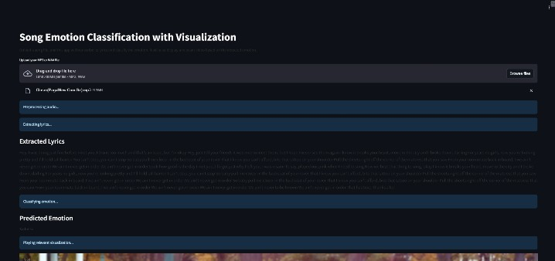
Figure 14: The music video for the song "/music."
- Identifying Raga Based on Mood, Time, and Tone:
The method correctly recommends the ideal raga according to musical qualities, mood, and time of day. The recommendations that users receive precisely match their interests, and they gain a deeper understanding of the raga with the help of extra contextual information like performance guidelines and historical history. As represented in Figure 15,the visual summary further emphasizes how well the system aligns with user preferences. This method enhances the listener's entire experience by fostering a deeper connection with the traditional art form in addition to providing personalized musical selections.
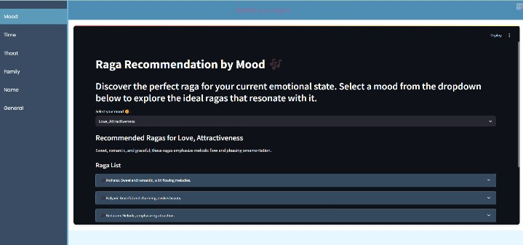
Figure 15: Ragah recommendation with the parameters.

- Traditional Music Exploration:
This module enables users to easily explore traditional ragas by filtering based on mood, regional classification, or specific raga names. The system provides detailed information about each raga's emotional context, cultural background, performance requirements, and suggested instruments, while also allowing visitors to listen to classic tunes directly. As represented in Figure 16,the intuitive presentation of this rich content deepens the user’s engagement with traditional music, ultimately enhancing their overall learning and listening experience.
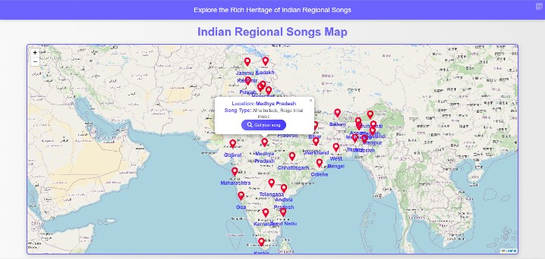
Figure 16: Traditional music is recommended.
- Custom Music Player:
The application's main core is the personalized music player, which smoothly incorporates functions like mood-based suggestions, raga recognition, personalized music creation, and traditional music discovery. enhances the experience of the user. The cohesive layout, as shown in Figure 17, clearly shows how each of these components cooperates to produce a seamless and captivating experience on all devices. All things considered, the design creates a captivating atmosphere that strengthens the listener's bond with the music.
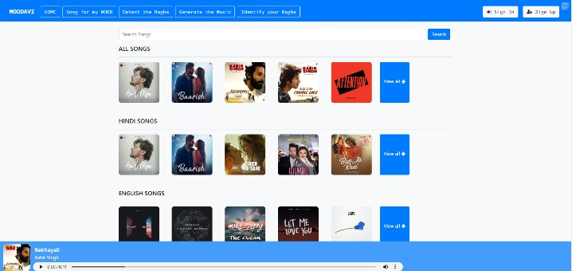
Figure 17: Personalize musical player.
The AI-Driven Personalized Music and Audio-Visual Relaxation System successfully satisfies a range of user needs for mental health and creative engagement, according to the pilot study. The modular design shows how AI can be used to build dynamic and responsive relaxing spaces by combining mood-based recommendations, culturally rich raga recognition, tailored music creation, and immersive audio-visual experiences. Positive user feedback on synchronized video production and personalized music generation highlights the usefulness of sophisticated methods like Sequential GANs, while the high accuracy attained in both the mood-based recommendation and raga classification modules confirms the resilience of the machine learning algorithms used. The system's responsiveness and customisation were maintained in large part via real-time feedback and adaptive learning algorithms, and user engagement was increased by the unified bespoke music player, which made feature navigation easy. However, there is need for improvement as seen by small latency problems with audio-visual synchronization and difficulties with the consistency of web-sourced contextual data for raga recommendations. All things considered, these results confirm the system's efficacy and offer a clear path forward for further advancements in providing customized, engrossing relaxation experiences.
- Conclusion and Future Scope
By providing a cohesive and immersive experience that promotes mental health and creative engagement, the AI-Driven Personalized Music and Audio-Visual Relaxation System successfully satisfies a variety of user needs. Its all-encompassing design, which incorporates synchronized audio-visual components, mood-based recommendations, culturally aware raga identification, and personalized music generation, demonstrates the power of its underlying techniques and its ability to provide individualized musical experiences that meet each person's needs for relaxation. This study shows that different systemic strategies effectively meet the unique needs for the best possible personal relaxation.
Future enhancements must to concentrate on improving audio-visual synchronization even more and guaranteeing the accuracy of contextual information derived from outside sources for raga suggestions. To further improve the user experience, more research might examine sophisticated personalization strategies and adaptive learning processes. The system's relevance and influence on individualized relaxation and mental health may also be enhanced by extending its capabilities to include a wider variety of musical genres and cultural situations.

VI References
[1] Ali, N., Nater, U. M., M., & The Authors. (2024). The effect of music on stress recovery. In University of Vienna & University Research Platform “The Stress of Life (SOLE) – Processes and Mechanisms underlying Everyday Life Stress,” Psychoneuroendocrinology (Vol. 168, p. 107137). https://doi.org/10.1016/j.psyneuen.2024.107137
[2] Verma, N. V., Marathe, N. N., Sanghavi, N. P., & Nitnaware, N. D. P. (2021). Music recommendation System using Machine learning. International Journal of Scientific Research in Computer Science Engineering and Information Technology, 80–88. https://doi.org/10.32628/cseit217615
[3] Rumiantcev, M., Khriyenko, O., & University of Jyväskylä. (2020). Emotion Based Music Recommendation System. In PROCEEDING OF THE 26TH CONFERENCE OF FRUCT ASSOCIATION [Conference-proceeding].
[4] Shah, D. P., Jagtap, N. M., Talekar, P. T., & Gawande, K. (2021). Raga Recognition in Indian Classical Music Using Deep Learning. In Lecture notes in computer science (pp. 248–263). https://doi.org/10.1007/978-3-030-72914-1_17
[5] John, S., Sinith, M. S., S, S. R., & P, L. P. (2020). Classification of Indian Classical Carnatic Music Based on Raga Using Deep Learning. 2020 IEEE Recent Advances in Intelligent Computational Systems (RAICS). doi:10.1109/raics51191.2020.9332482.
[6] Dong, H.-W., Hsiao, W.-Y., Yang, L.-C., & Yang, Y.-H. (2018). MuseGAN: Multi-track Sequential Generative Adversarial Networks for Symbolic Music Generation and Accompaniment. Proceedings of the AAAI Conference on Artificial Intelligence, 32(1). https://doi.org/10.1609/aaai.v32i1.11312.
[7] Bairwa, A. K., Bhat, S., Sawant, T., & Manoj, R. (2024). MGU-V: A Deep Learning Approach for Lo-Fi Music Generation Using Variational Autoencoders with State-of-the-Art Performance on Combined MIDI Datasets. IEEE Access, 12, 143237-143251. https://doi.org/10.1109/ACCESS.2024.3471918.
[8] Han, X., Chen, F., & Ban, J. (2023). Music Emotion Recognition Based on a Neural Network with an Inception-GRU Residual Structure. Electronics, 12(4), 978. https://doi.org/10.3390/electronics12040978
[9] Tony, Suman & Subramanian, Sasikumar. (2022). Investigation on Automatic Music Generation Using Gan and Lstm Networks. 10.21203/rs.3.rs-2376478/v1.
[10] MUSIC EMOTION RECOGNITION AND CLASSIFICATION USING HYBRID CNN-LSTM DEEP NEURAL NETWORK. (2024). Bangladesh Journal of Multidisciplinary Scientific Research, 21–32. https://doi.org/10.46281/bjmsr.v9i3.2230
[11]Agga, A., Abbou, A., Labbadi, M., Houm, Y. E., & Ali, I. H. O. (2022). CNN-LSTM: An efficient hybrid deep learning architecture for predicting short-term photovoltaic power production. Electric Power Systems Research, 208, 107908. https://doi.org/10.1016/j.epsr.2022.107908
[12]Aziz, M. N. (2020). A Review on Artificial Neural Networks and its’ Applicability. Bangladesh Journal of Multidisciplinary Scientific Research, 2(1), 48-51. https://doi.org/10.46281/bjmsr.v2i1.609
[13]Aksan, F., Li, Y., Suresh, V., & Janik, P. (2023). CNN-LSTM vs. LSTM-CNN to Predict Power Flow Direction: A Case Study of the High-Voltage Subnet of Northeast Germany. Sensors, 23(2), 901. https://doi.org/10.3390/s23020901
[14]Aljanaki, A., Yang, Y. H., & Soleymani, M. (2017). Developing a benchmark for emotional analysis of music. PloS One, 12(3), e0173392. https://doi.org/10.1371/journal.pone.0173392
[15]Kılıç, B.; Aydın, S. Classification of Contrasting Discrete Emotional States Indicated by EEG Based Graph Theoretical Network Measures. Neuroinformatics 2022, 20, 863–877. https://doi.org/10.1007/s12021-022-09579-2
[16]Yang, Y.H.; Lin, Y.C.; Su, Y.F.; Chen, H.H. A regression approach to music emotion recognition. IEEE Trans. Audio Speech Lan-guage Process. 2008, 16, 448–457. https://doi.org/10.1109/TASL.2007.911513.
[17]Han, B.J.; Rho, S.; Dannenberg, R.B.; Hwang, E. SMERS: Music Emotion Recognition Using Support Vector Regression. In Pro-ceedings of the 10th International Society for Music Information Retrieval Conference (ISMIR 2009), Kobe, Japan, 26–30 October2009; pp. 651–656.
[18]Koh, E.; Dubnov, S. Comparison and analysis of deep audio embeddings for music emotion recognition. arXiv preprint 2021,arXiv:2104.06517.
[19]Eerola, T.; Vuoskoski, J.K. A comparison of the discrete and dimensional models of emotion in music. Psychol. Music 2011, 39,18–49. https://doi.org/10.1177/0305735610362821.
[20]Wang, Yaohua & Chen, Haoqi. (2024). An improved random forest model for music genre classification algorithm based on sparrow search algorithm. Applied and Computational Engineering. 77. 84-90. 10.54254/2755-2721/77/20240658.
[21] S. John, M. S. Sinith, S. R. S and L. P. P, "Classification of Indian Classical Carnatic Music Based on Raga Using Deep Learning," 2020 IEEE Recent Advances in Intelligent Computational Systems (RAICS), Thiruvananthapuram, India, 2020, pp. 110-113, doi: 10.1109/RAICS51191.2020.9332482.

